Study Skills for Spelling

The following are suggestions students may use to help learn spelling words. Please note that some methods work better with some children and that different strategies may have to be employed depending on the word to be learned.

- ANALYZE THE WORD
THINK ABOUT WHAT YOU ALREADY KNOW AND WHAT IS TRICKY ABOUT A WORD.
MAKE CONNECTIONS. FOR EXAMPLE:

• Find a small word you know within the big word.

bonjour bon, jour, on

• See if the word resembles another word you already know how to spell.

bien chien

• Look at the word, say it, then decide if the word can be written exactly as it is said
(i.e there are no silent letters, etc).

midi “Yes, it's spelled as it sounds.”
petit “No, it's not spelled as it sounds. There is a silent "t" at the end.”

- NOW STUDY THE WORD.
YOU WILL REMEMBER THE WORD BETTER IF YOU ARE LOOKING AT THE LETTERS (see), SAYING THE SOUNDS (hear) AND WRITING THE LETTERS (feel/do). THESE ARE THE 3 LEARNING CHANNELS.

- Look at the word (see suggestions above).
- Say the word while looking at it, then say either the individual letter sounds, the letter names or the syllables in the word.
- Cover the word, then write it out (on paper, on whiteboard). Say the letters or syllables as you write.
- Check to see if you spelled the word correctly. Check letter by letter.
- If you spelled the word incorrectly, think about what you forgot or wrote incorrectly. Find a trick to help you remember. Practice the word several times again by doing this:
“LOOK-SAY-COVER-WRITE-CHECK”

Here is a website you can use to practice spelling words, too, just to add some fun. You will find it under "Spelling" on the blog:
http://brigitteprof.brigitteleonard.com/wp-content/uploads/2012/01/valise/index.html

Click and drag the letters in the trunk into the rectangle to make your word. Don’t forget the correct accent! Once you have completed the word, hit ENTER to refresh the page. You will see an example of the website on the back of this page.

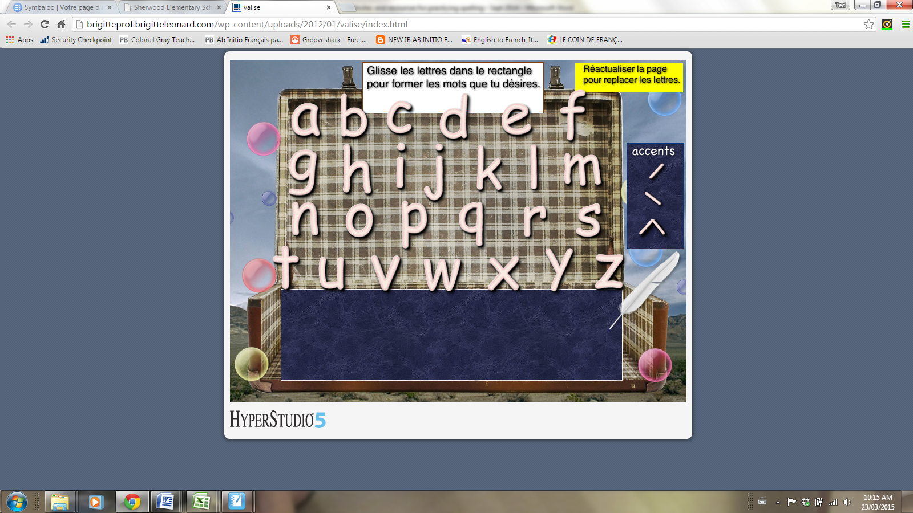

Some students who have particular difficulty remembering proper spelling may need a little more practice saying/hearing/doing in order to get the word into memory. Here are a few more suggestions.

• Look at the word and say each letter, then say the letters without looking at the word.

ami a, m, i

• Clap your hands for each letter in the word.

vite v/i/t/e

• Clap your hands as you separate the words into syllables, or cut it up into syllables on a piece f paper.

cataradi ca ta ra di

• Use memory tricks to help remember a word.
Refer to the sheet “My Tricks” from my blog (under “Spelling”)

fête I wear a hat (ê) to a party (fête)

gros There's a gros (big) S at the end of "gros"

